H2O AI Cloud

**Make, Operate and Innovate with AI**

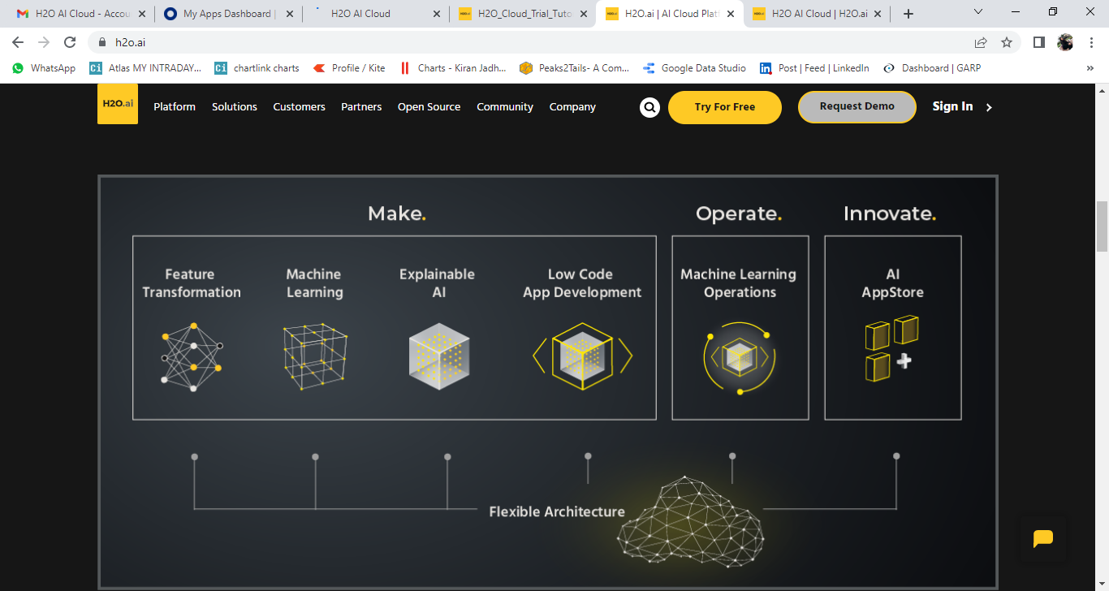

***H2O AI Cloud*** *is an end-to-end platform that enables organizations to rapidly build world-class AI models and applications in the cloud or on premise. The platform comes with an* ***AppStore*** *that simplifies access to business applications, data science best practices, and allows for rapid* ***prototyping and collaboration****.*

*This platform was designed to* ***accelerate the entire machine learning lifecycle*** *including data ingestion, feature engineering, modelling, interpreting, and deploying models into production.*

*In the* ***enterprise version*** *of the H2O AI Cloud, we can use our open-source SDK, Wave, to build any style of app you choose. It is a python-based SDK that can leverage any python library so you can have complete control and freedom of what apps you develop*.

**WHAT TO EXPECT**

* AI application store
* AutoML integration
* Machine learning interpretability
* Automated model documentation
* Deployment and model monitoring

**App Store**

This includes over TWENTY SAMPLE APPLICATIONS ranging from data science best practice apps to examples of industry vertical solutions. You can also easily provision an AI engine for automatically building predictive models and deploy these models as REST endpoints.

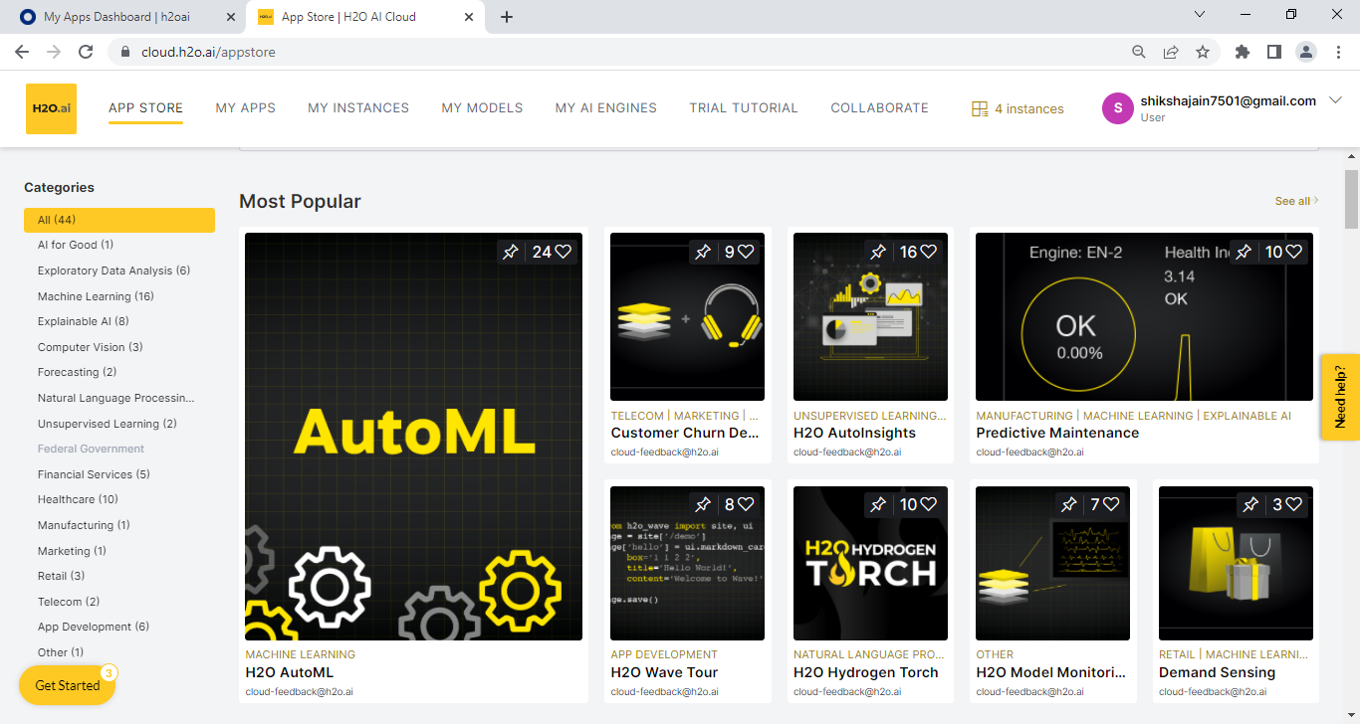

**LET’S SEE SOME EXAMPLES**

1. **FINANCIAL SERVICES**

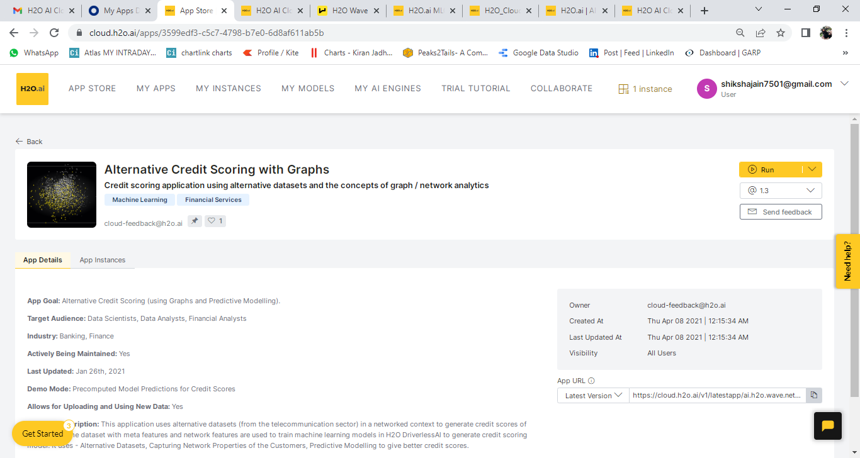

* This application uses alternative datasets (from the telecommunication sector) in a networked context to **generate credit scores of individuals**. The dataset with Meta features and network features are used to train machine learning models in H2O Driverless AI to generate credit scoring model. It uses - Alternative Datasets, Capturing Network Properties of the Customers, Predictive Modelling to give better credit scores.

**AI Make, Operate and Innovate**

* **App Goal:** Alternative Credit Scoring (using Graphs and Predictive Modelling).
* **Target Audience:** Data Scientists, Data Analysts, Financial Analysts
* **Industry:** Banking, Finance
* **Actively Being Maintained:** Yes

**2. FORECASTING RISK WITH CREDIT CARDS AND DECISION MAKING**

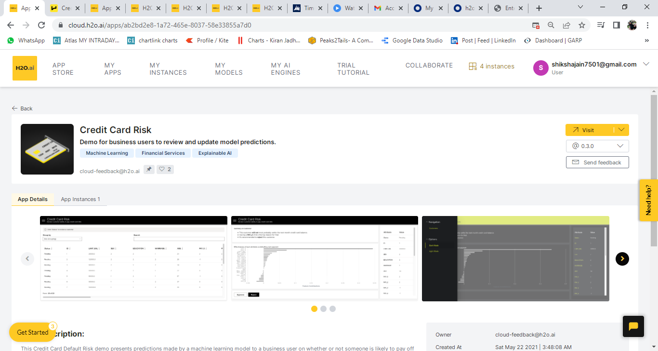

* This **Credit Card Default Risk** demo presents **predictions** made by a **machine learning** model to a business user on whether or not someone is likely to pay off their credit card. The user can review each predict and make the final say on if the applicant is approved or denied. This is purely a demonstration of including a human-in-the-loop with machine learning modelling.

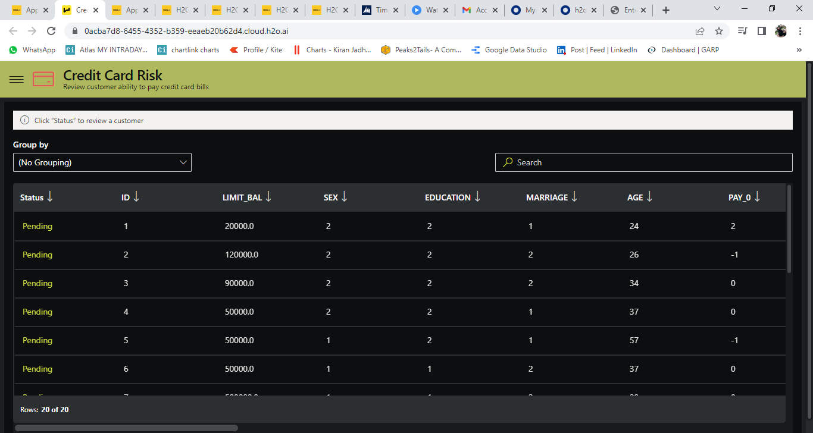

**Audience:** Business Analyst, Financial Services Risk team, Business Owner

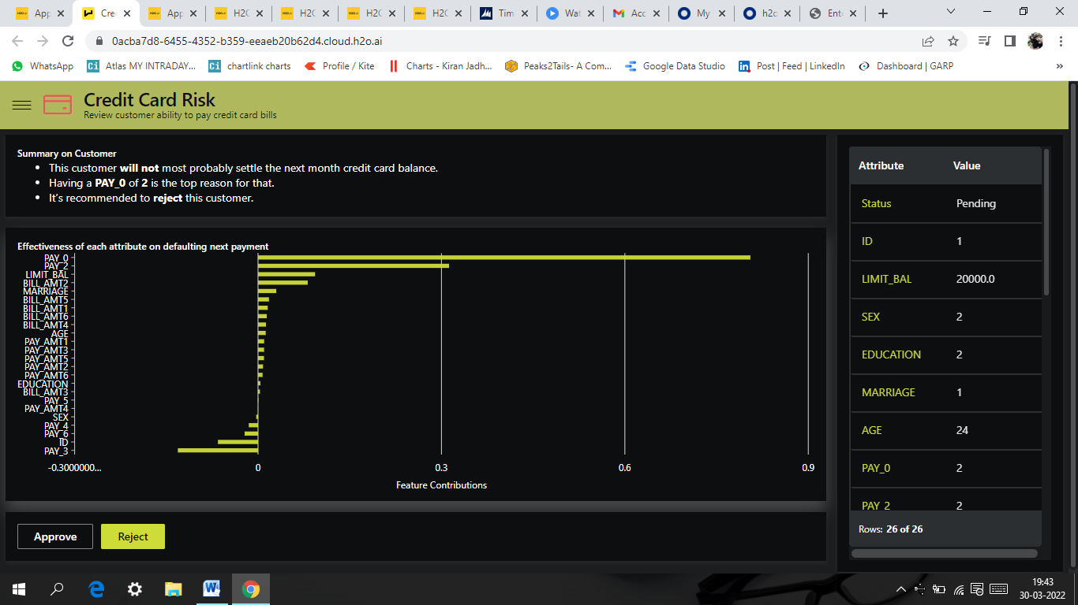

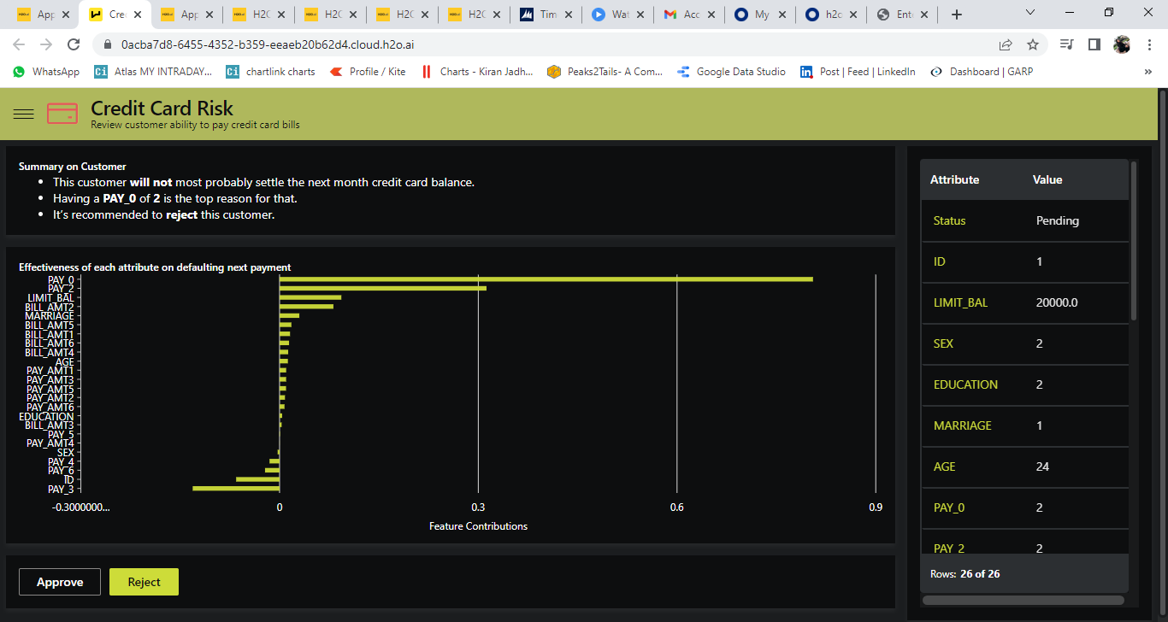DECISION MAKING

1. **ANOMALY DETECTION**

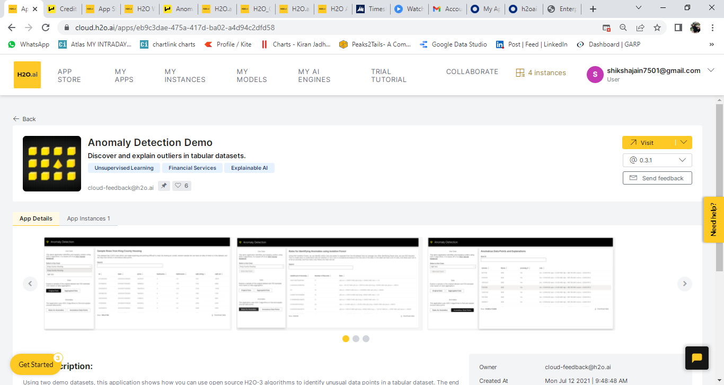

* This application shows how you can use open source H2O-3 algorithms to **identify unusual data points** in a tabular dataset. The end user is able to see both the anomalous rows but is also provided with rules for why the point is considered an outlier.
* 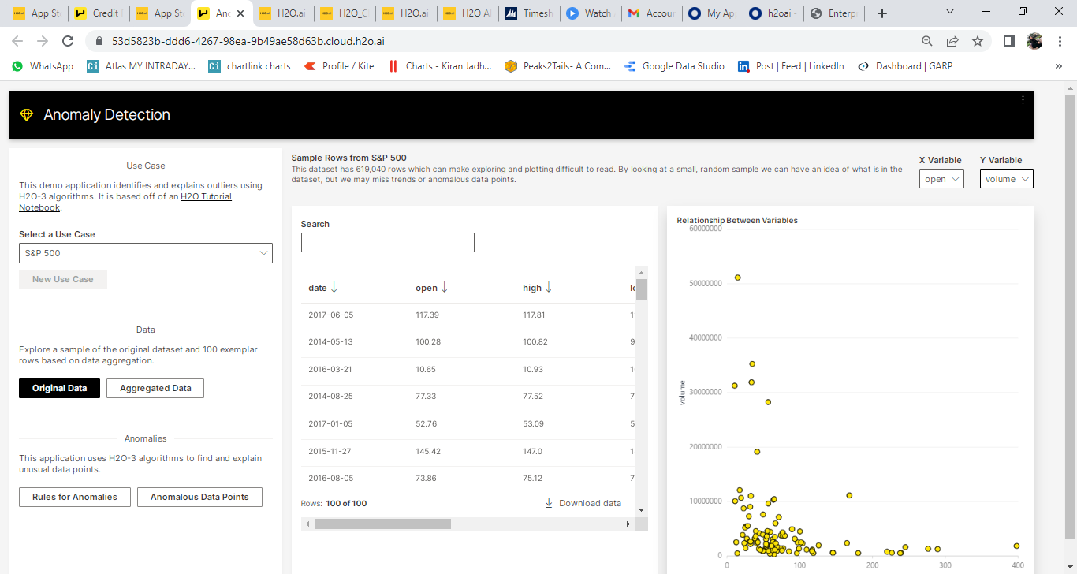**Audience:** Data Scientists and Business Domain Experts

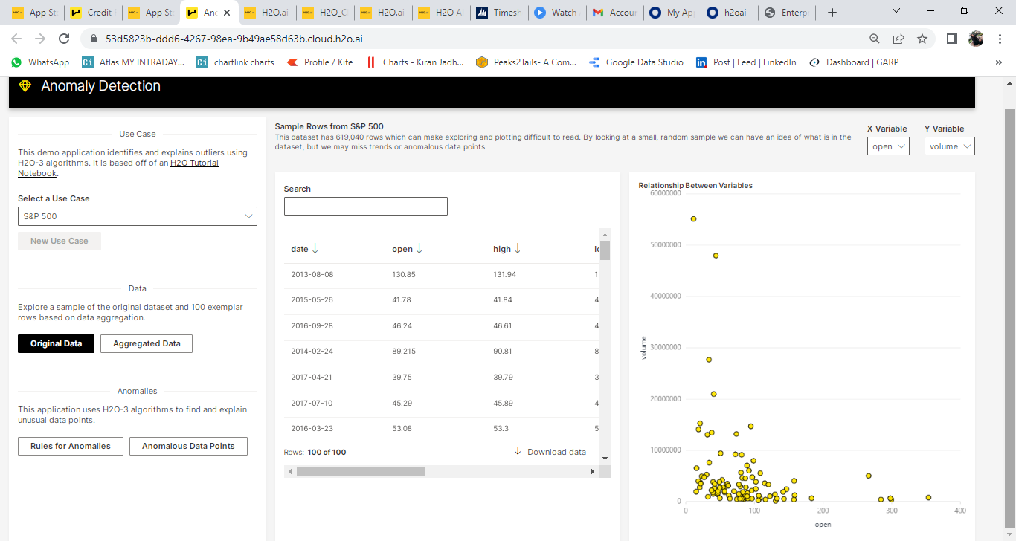

VARIABLE SELECTION

OUTLIERS

**Products Used**

**H2O-3:** H2O-3 is a fully open-source, distributed, in-memory machine learning platform with linear scalability. H2O-3 supports the most widely used statistical and machine learning algorithms, including gradient boosted machines, generalized linear models, deep learning, and more.

**H2O Wave:** H2O Wave is an open-source Python development framework that makes it fast and easy for data scientists, machine learning engineers, and software developers to develop real-time interactive AI apps with sophisticated visualizations